Solve the following

1. write a procedure to insert record into employee table.

the procedure should accept empno, ename, sal, job, hiredate as input parameter

write insert statement inside procedure insert_rec to add one record into table

delimiter //

create procedure insert_rec1(peno int,pnm varchar(20),psal decimal(9,2),pjob

varchar(20),phiredate date)

begin

insert into emp(empno,ename,sal,job,hiredate)

values(peno,pnm,psal,pjob,phiredate)

end//

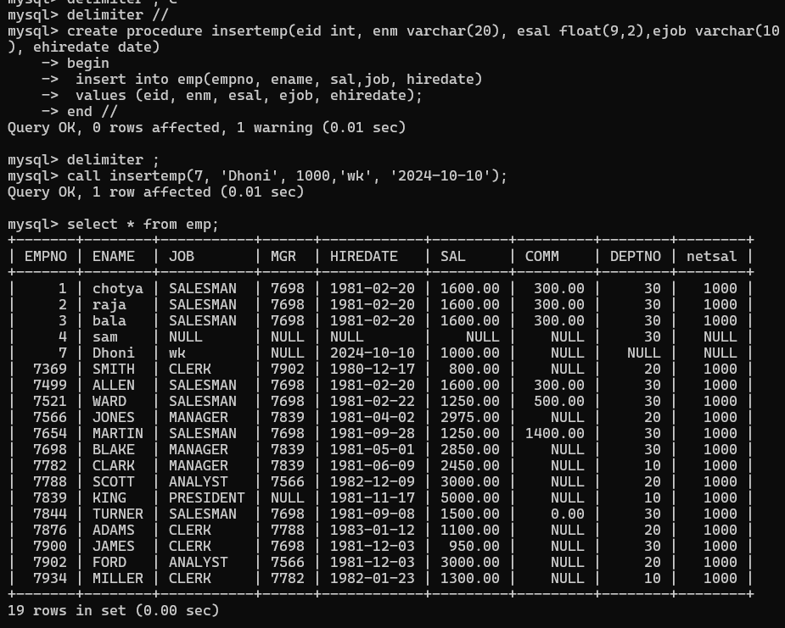

2. write a procedure to delete record from employee table.

the procedure should accept empno as input parameter.

write delete statement inside procedure delete_emp to delete one record from emp

Table

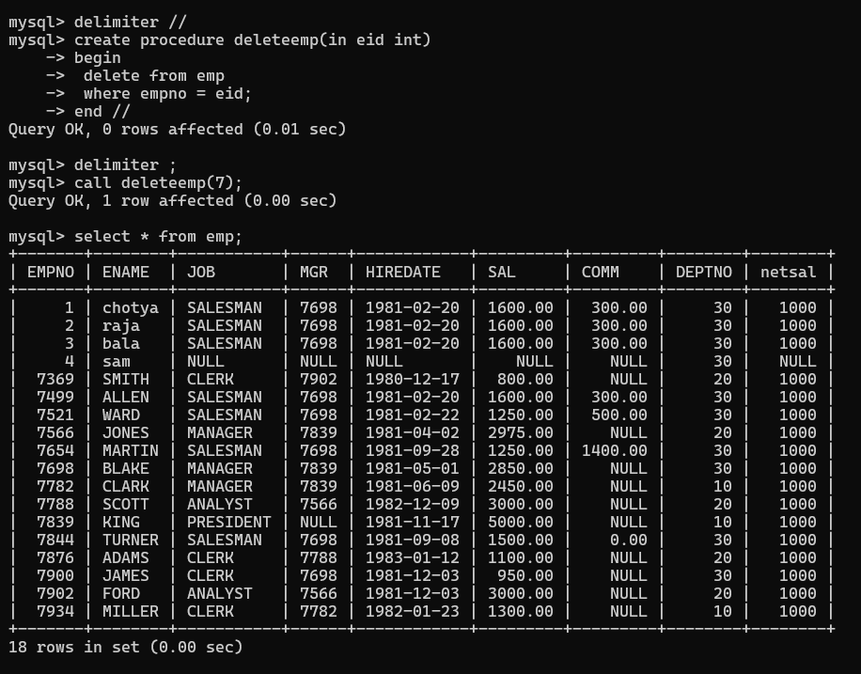

3. write a procedure to display empno,ename,deptno,dname for all employees with sal

> given salary. pass salary as a parameter to procedure

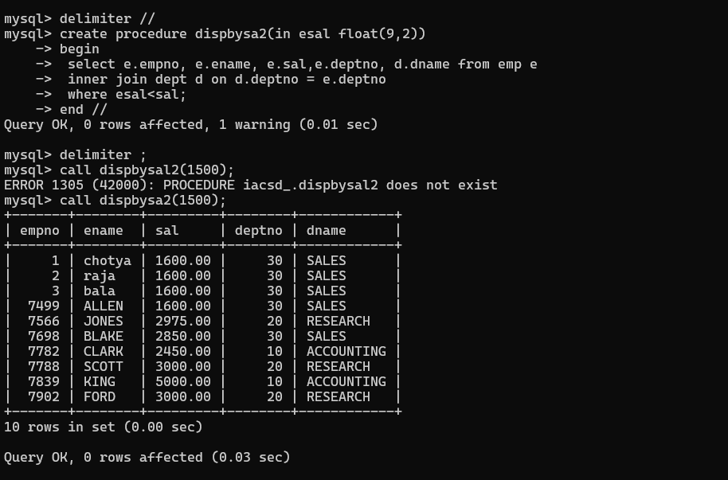

4. write a procedure to find min,max,avg of salary and number employees in the

given deptno.

deptno --→ in parameter

min,max,avg and count ---→ out type parameter

execute procedure and then display values min,max,avg and count

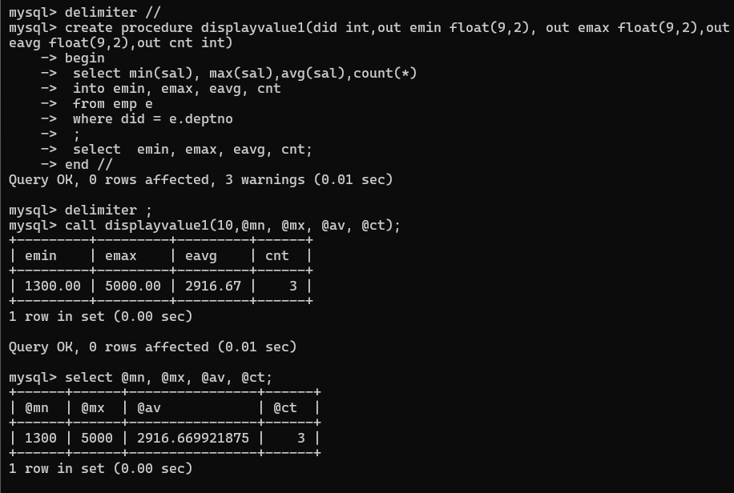

5. write a procedure to display all pid,pname,cid,cname and salesman name(use

product,category and salesman table)

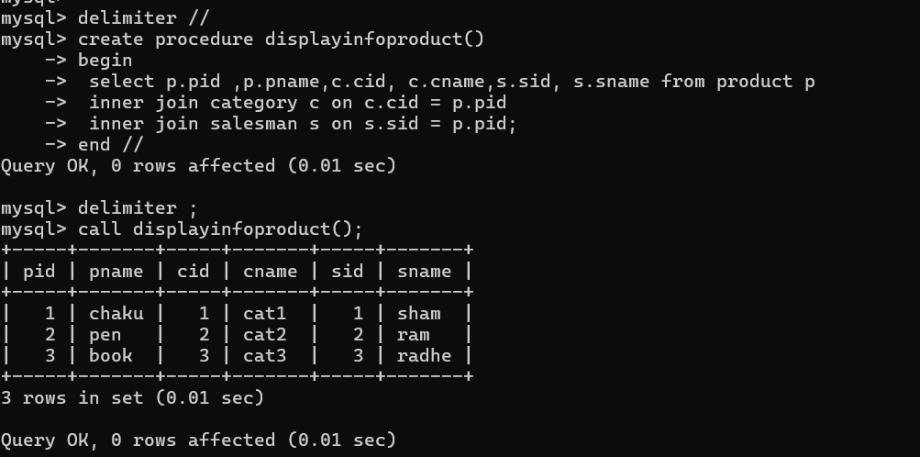

6. write a procedure to display all vehicles bought by a customer. pass customer name as

a parameter.(use vehicle,salesman,custome and relation table)

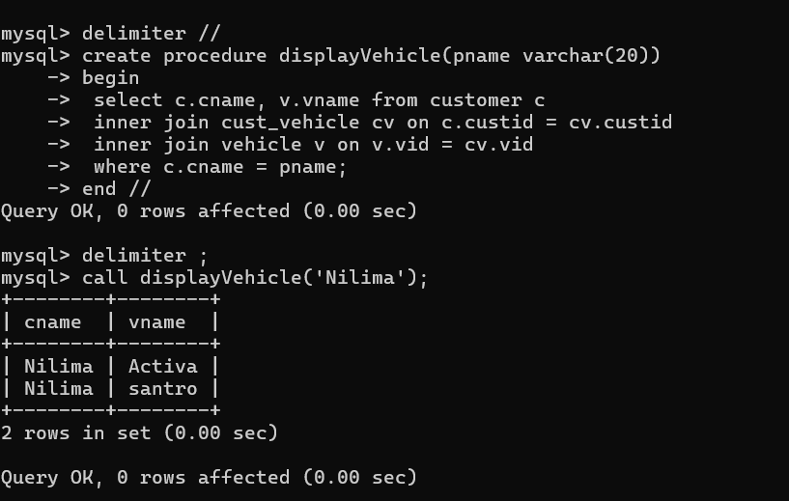

7. Write a procedure that displays the following information of all emp

Empno,Name,job,Salary,Status,deptno

Note: - Status will be (Greater, Lesser or Equal) respective to average salary of their own

department. Display an error message Emp table is empty if there is no matching

Record.

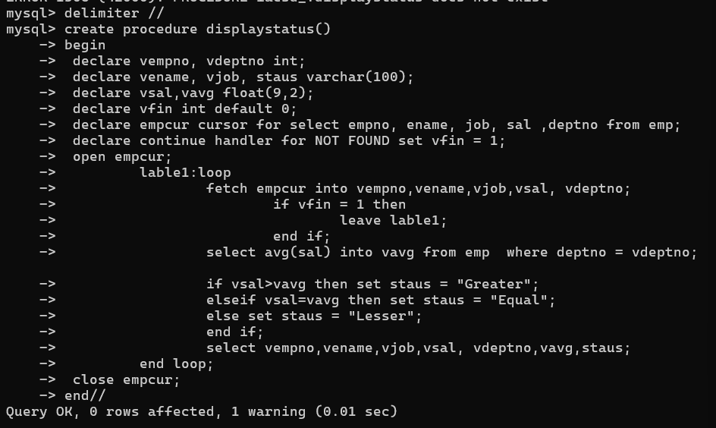

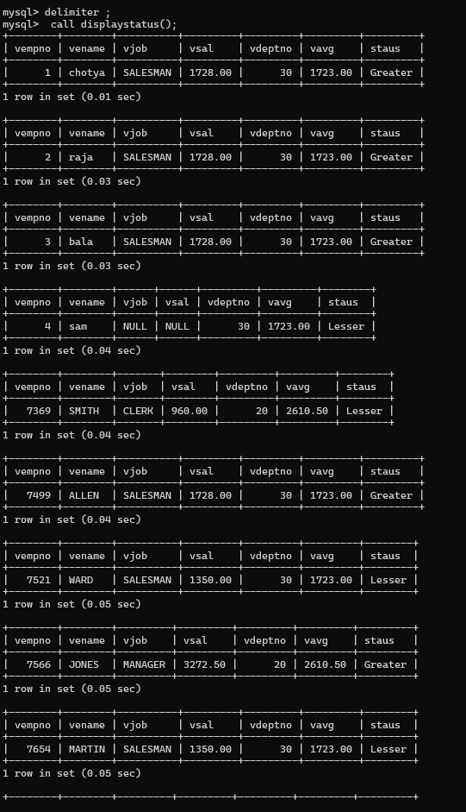

8. Write a procedure to update salary in emp table based on following rules.

Exp< =35 then no Update

Exp> 35 and <=38 then 20% of salary

Exp> 38 then 25% of salary

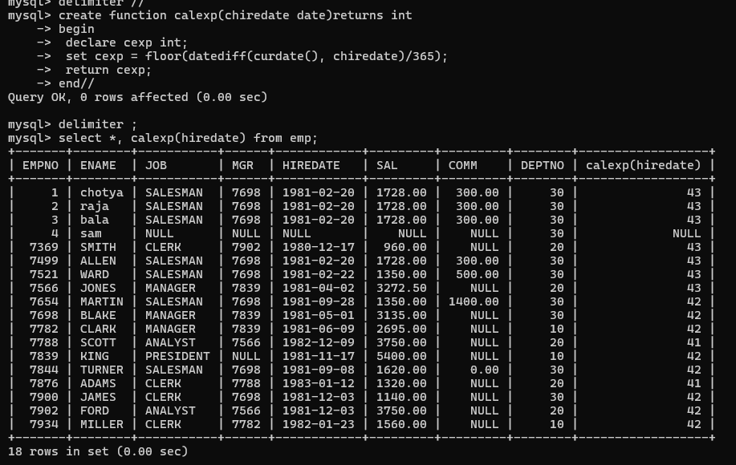

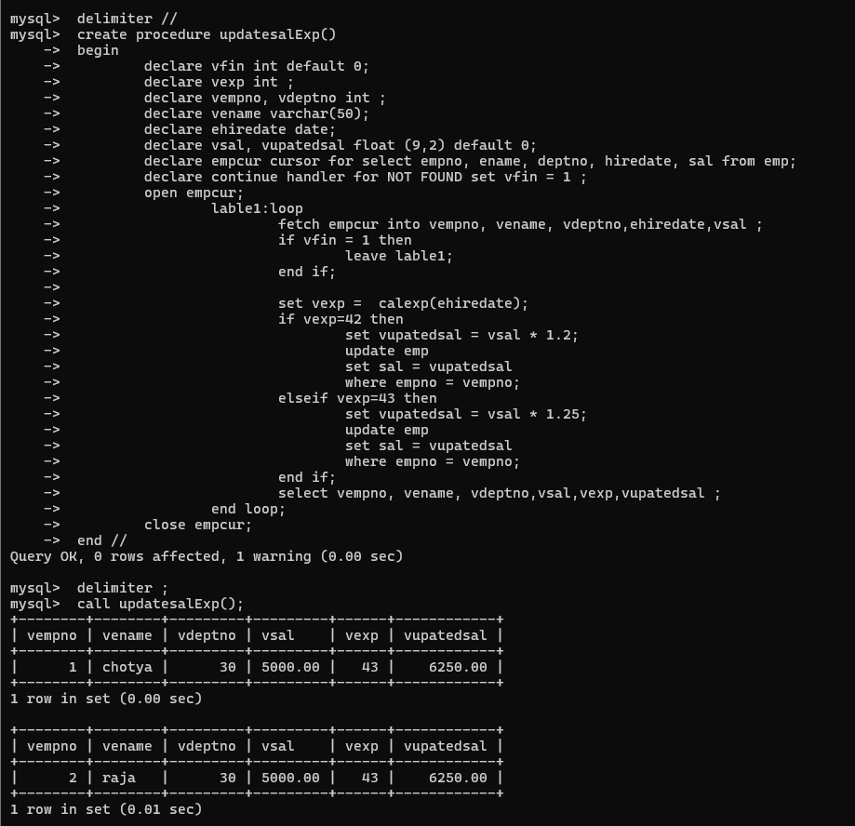

9. Write a procedure and a function.

Function: write a function to calculate number of years of experience of employee.(note:

pass hiredate as a parameter)

Procedure: Capture the value returned by the above function to calculate the additional

allowance for the emp based on the experience.

Additional Allowance = Year of experience x 3000

Calculate the additional allowance

and store Empno, ename,Date of Joining, and Experience in

years and additional allowance in Emp_Allowance table.

create table emp_allowance(

empno int,

ename varchar(20),

hiredate date,

experience int,

allowance decimal(9,2));



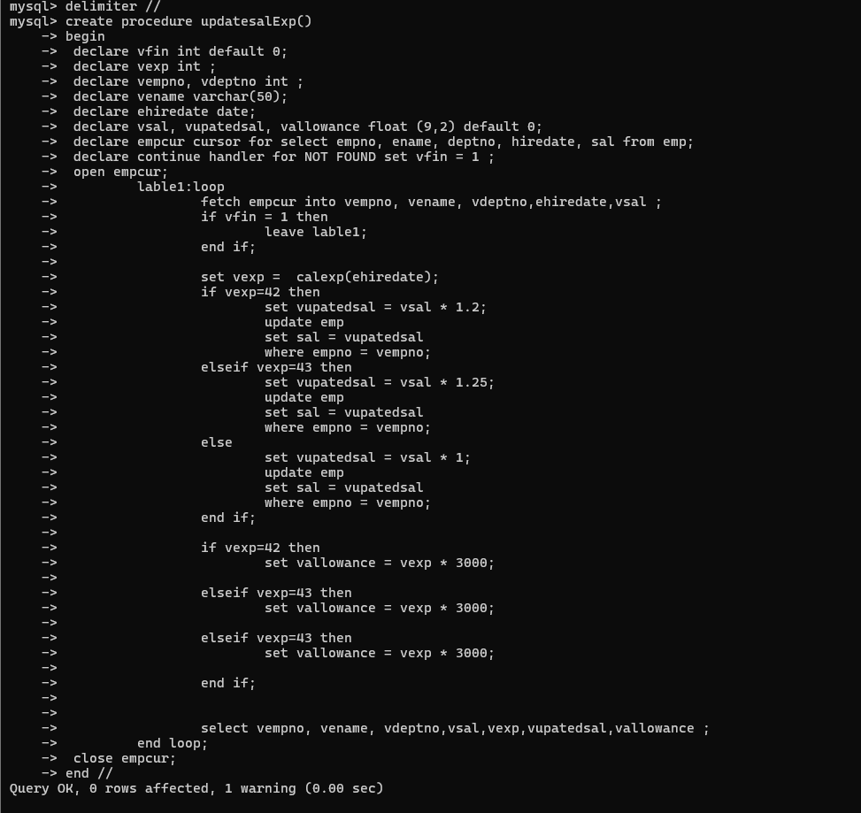

10. Write a function to compute the following. Function should take sal and hiredate

as i/p and return the cost to company.

DA = 15% Salary, HRA= 20% of Salary, TA= 8% of Salary.

Special Allowance will be decided based on the service in the company.

< 1 Year Nil

>=1 Year< 2 Year 10% of Salary

>=2 Year< 4 Year 20% of Salary

>4 Year 30% of Salary

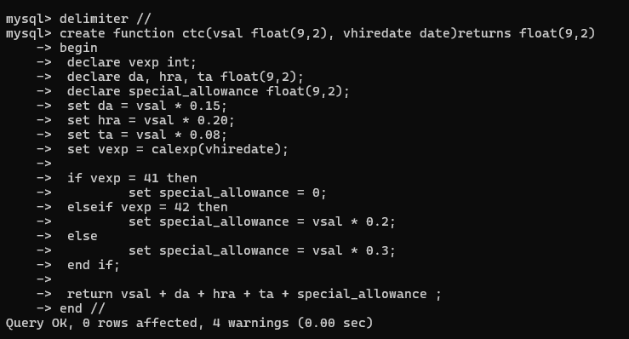

11. Write query to display empno,ename,sal,cost to company for all employees(note:

use function written in question 10)

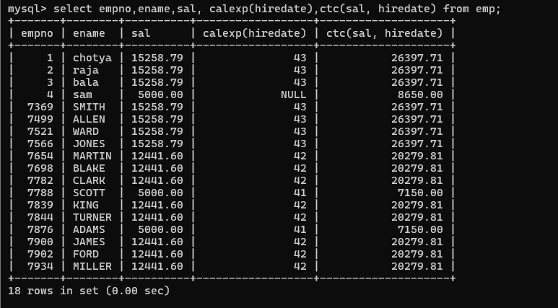

Q2. Write trigger

1. Write a tigger to store the old salary details in Emp _Back (Emp _Back has the

same structure as emp table without any

constraint) table.

(note :create emp_back table before writing trigger)

----- to create emp_back table

create table emp_back(

empno int,

ename varchar(20),

oldsal decimal(9,2),

newsal decimal(9,2)

)

(note :

execute procedure written in Q8 and

check the entries in EMP_back table after execution of the procedure)

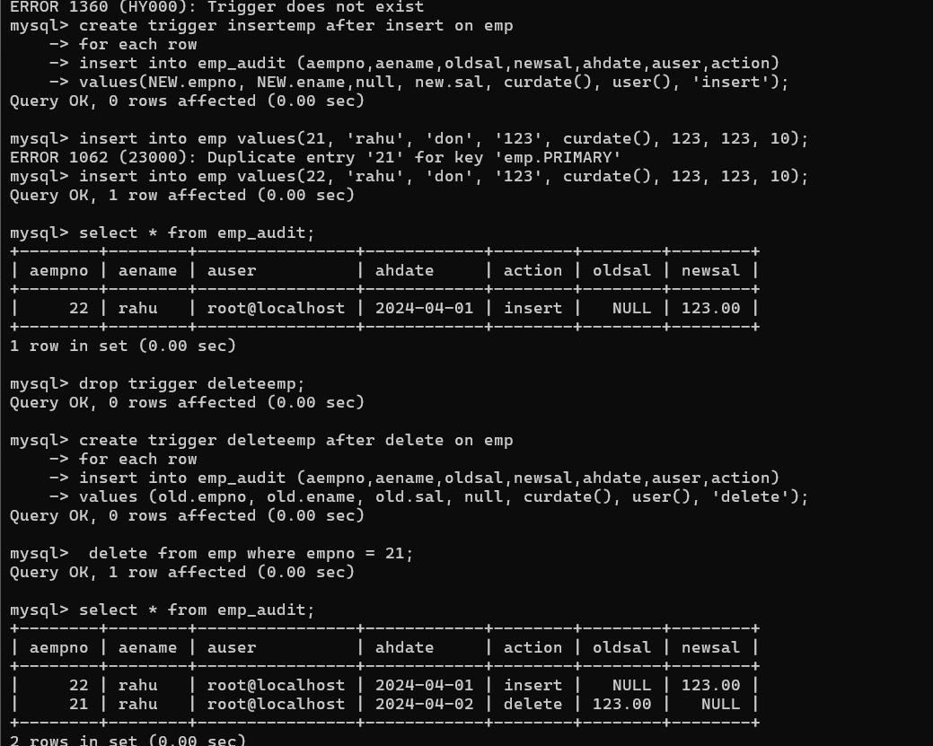

2. Write a trigger which add entry in audit table when user tries to insert or delete

records in employee table store empno,name,username and date on which

operation performed and which action is done insert or delete. in emp_audit table.

create table before writing trigger.

create table empaudit(

empno int;

ename varchar(20),

username varchar(20);

chdate date;

action varchar(20)

);

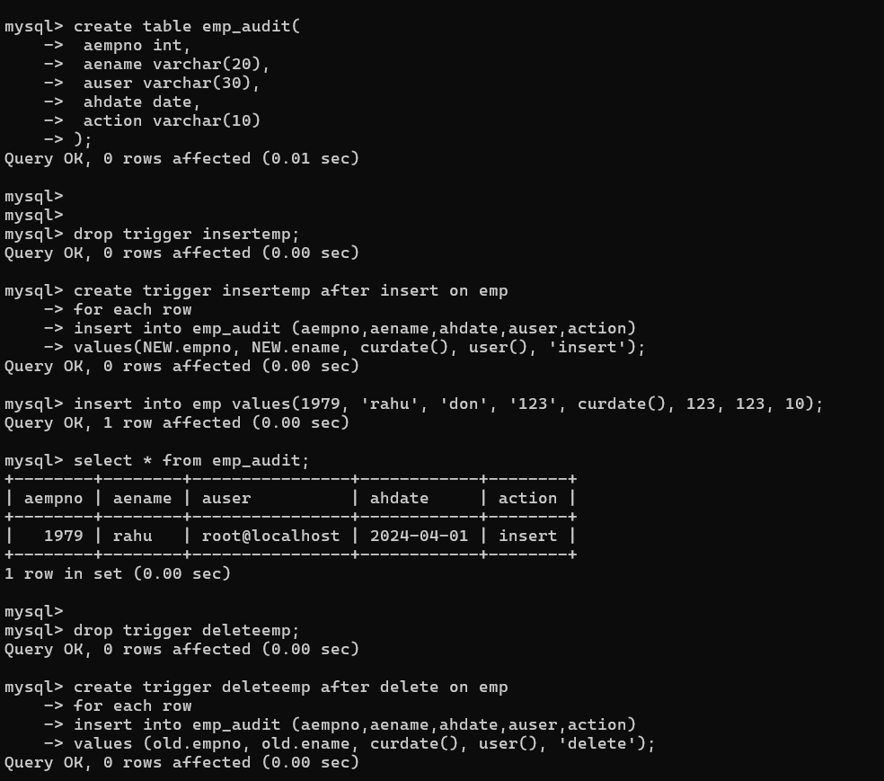

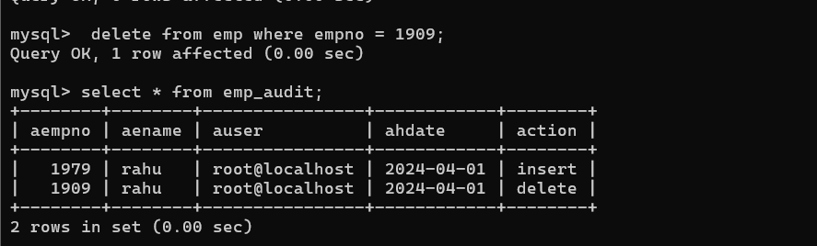

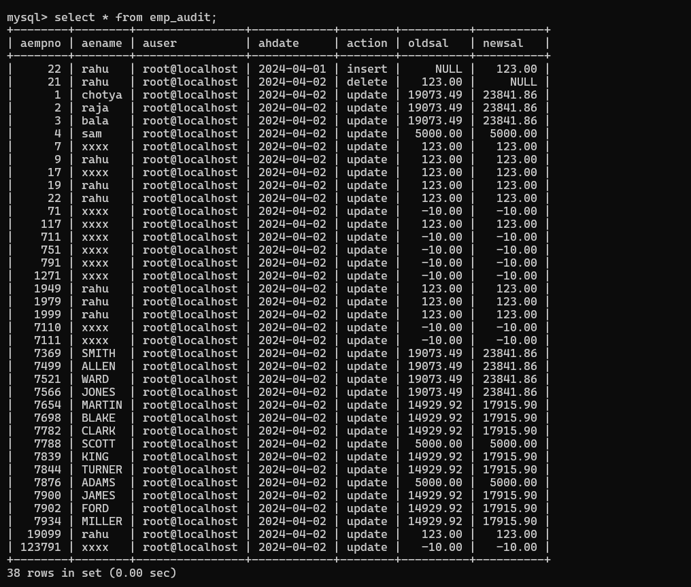

3. Create table vehicle_history. Write a trigger to store old vehicleprice and new vehicle

price in history table before you update price in vehicle table

(note: use vehicle table).

create table vehicle_history(

vno int,

vname varchar(20),

oldprice decimal(9,2),

newprice decimal(9,2),

chdate date,

username varchar(20)

);

